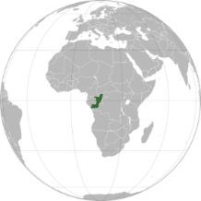
CAREER OPPORTUNITY

PROJECT COORDINATOR CARBON & PLANTATION (M/W/X)

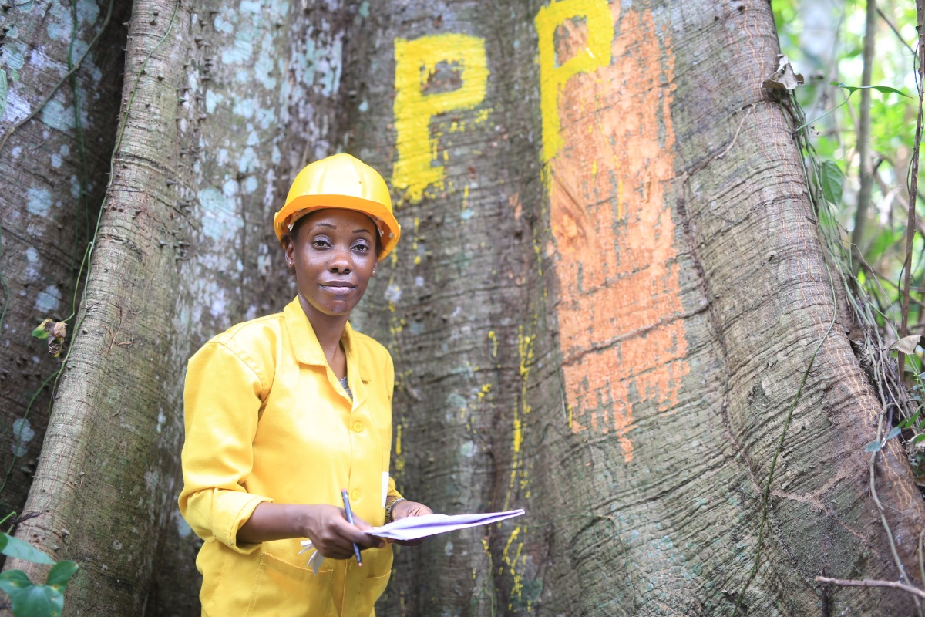

Are you passionate about sustainability and willing to make a real difference for the future? Do you want to be a part of innovative projects where you can express your problem solving skills? Are you interested in gaining international experience and advancing your career?

So, welcome to Interholco!

Since close to sixty years, Interholco has been advancing its leadership in the sustainable management of forests.

With both its FSC certification and its values of technological excellence and human development; the Interholco group (IHC) produces and distributes, through its subsidiary IFO, logs, lumber and other finished wood products from Africa’s forests as well as several product lines from its trading department.

IFO (Industrie Forestière de Ouesso) responsibly manages a forest concession of around 1.1 million hectares in Congo Brazzaville and keeps on growing thanks to the commitment, expertise, and diversity of its 1’000 team members.

OVERVIEW

As a Project Manager Carbon and Plantation, you contribute to developing our new carbon projects (reduced emissions in forest operations, biomass, plantation), as well as help us analyse and realize plantation projects

You also play a key role in supporting our Head of Sustainability.

YOUR MOBILITY

You have a flexibility where you combine remote/home working with regular visits to IHC headquarters in Baar Switzerland and international travel, including visits to our industrial operations in Congo Brazzaville.

All in all, international travel counts for 20% approximately in this role.

YOUR ROLE

Reporting directly to the Head of Sustainability, you :

- Support the development of carbon credit projects.

- Support the development of plantation and afforestation projects.

- Provide administrative follow-up in several/topics.

YOUR RESPONSIBILITIES

- Keep close contact with project development partners and internal teams.

- Make budgets and work-plans, and follow up on timelines and costs.

- Prepare, initiate, and maintain overall project documentation.

- Follow-up on chain of custody issues (contact with suppliers, follow-up and request documentation from suppliers and internally).

- Provide status reports on ongoing projects.

- Build relationships with funding partners.

- Actively participate in providing ideas for new projects/concepts.

- Stay abreast of latest developments, methodologies, or processes, which can be used to further improve operations.

- Maintain the department schedule and track/maintain project timelines.

- Support cost estimation for future and/or potential projects for budget and feasibility purposes, including return on investment potential.

YOUR PROFILE

- Able to demonstrate leadership and ability to drive decision making.

- Able to work cross functional teams.

- Excellent communication skills and interpersonal skills.

- Strong analytical skills, coupled with and ability to present ideas in simple terms.

- Able to work independently, self-motivated, pragmatic, forward-thinking.

- Data analytics skills and experience.

- Organizational, planning, and documentation skills.

- Keen attention to detail

YOUR COMPETENCE AND QUALIFICATIONS

- Knowledge of project management principles. Proficient use of tools and software such as MS Project or other systems would be a plus.

- Work knowledge or experience in tropical forest management, carbon and/or plantation business, would be an advantage.

- BSC or Master degree preferably in one of the following:

- Business Administration
- Environmental science
- Forestry

- Minimum 2-5 years relevant work experience in nature conservation, environmental sciences or forestry.

- Experienced user of Microsoft Office programs.

- Proficiency in English and French language.

YOUR AVAILABILITY

Immediate

WHY JOIN US

- You experience a unique adventure enabling you to be a part of sustainable development and shape the future.

- You accelerate your professional growth by joining a multicultural, multidisciplinary team of experts, engineers, and managers; all committed to building solutions.

- You receive an attractive, comprehensive compensation package.

HOW TO JOIN US

We welcome your interest in the form of a CV and letter at HR@interholco.com.

