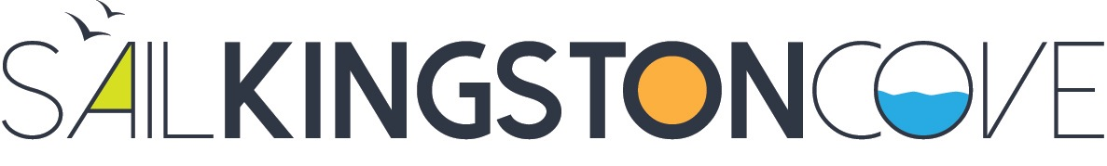

SAIL KINGSTON COVE YOUTH EVENTS RELEASE, HOLD HARMLESS AND ASSUMPTION OF RISK
I/We understand that participation in events organized by Sail Kingston Cove and its related activities, both on and off the water, inherently involves potential hazards and risks of damage to property and bodily injury, even death. I/We further understand that participation in events organized by Sail Kingston Cove may involve strenuous activity. I/We hereby affirm that the participant has no medical or physical condition(s) which prevent or limit their ability to engage in these activities. I/We acknowledge that the participant is able to swim. I/We will immediately notify The Sailing Director, if a change in the participant’s health or other condition would affect their ability to participate in the sailing related activities. I/We willingly assume all of these risks from hazards, both known and unknown.

Having read this waiver and knowing these facts, and in consideration of being allowed to participate in events organized by Sail Kingston Cove, I hereby for myself, my marital community (if applicable), my heirs, executors, administrators, or anyone else who might claim on my behalf, covenant not to sue, and with this agreement do release, discharge, hold harmless and agree to defend and indemnify the instructors, volunteers, affiliated community organizations and yacht clubs, all other sponsors of Sail Kingston Cove Youth Sailing Program, suppliers, agents, and their respective Boards of Directors, employees, members, insurers, agents, all others acting on their behalf and any other personnel or entity in any way assisting or connected with this event from any and all claims of liability for any damages, injuries or other loss of any nature arising in any manner from participation in an event organized by Sail Kingston Cove.

I intend this Release, Hold Harmless and Assumption of Risk to be effective whether my participation in Sail Kingston Cove Youth Sailing Program is as a student, instructor, victim, or in any other capacity. This agreement shall remain in effect until Sail Kingston Cove receives written notice of the cancellation of the consent.

I/WE HAVE CAREFULLY READ THIS AGREEMENT AND FULLY UNDERSTAND ITS CONTENTS. I/WE AM/ARE AWARE THE AGREEMENT INCLUDES A WAIVER OF LIABILITY, AN ASSUMPTION OF RISK AND AN AGREEMENT BY ME/US TO INDEMNIFY THE RELEASEES, AND I/WE SIGN IT OF MY/OUR OWN FREE WILL.

Participant’s Name:

Participant’s Signature: Date:

Parent/Legal Guardian’s Signature (if participant is under 18): Date:

Parent/Legal Guardian’s Signature (if participant is under 18): Date:

