Charter for the use of the HPSU room
Come in
- HEC Paris Students Union ("HPSU"), a non-profit association governed by the law of 1901, and represented by Arthur LAMY, acting in his capacity as President; and
- [•] ("the Club"), an HPSU club, and represented by [•], acting in his capacity as President;
The following has been agreed for the purposes hereof.
Article 1 – Purpose
The purpose of this charter is to regulate the occasional use of the HPSU room, located on the ground floor of building B1, by the Club.
Article 2 – Price, duration and authorisation of use
The use of the premises is granted free of charge by HPSU for the benefit of the Club.
Its duration is punctual and will be defined by any means between HPSU and the Club. An online Excel file will be made available for consultation by HPSU clubs. This Excel file will be proof of the authorization of use by HPSU.
Article 3 – Deposit
In order to mitigate the consequences of any damage, loss, destruction or theft of equipment, the Club will pay for the purchase of a guarantee ("Deposit") on the HPSU website. Failure to pay will result in the nullity of the authorization.
The amount of the deposit is seventy five (€75), divided into two instalments:
- fifty euros (€50) for any damage, loss, destruction or theft of equipment;
- twenty five (€25) for the cleanliness of the premises at the time of return, or any exceptional and outstanding kind of disturbance.
The deposit may be withheld, in whole or in part and without time limit, according to a fraction freely determined by HPSU. Where applicable, HPSU will act in good faith in order to comply with the principle of no loss or profit.
Conversely, in the case of use in accordance with this Charter, and subject to any other express agreement between the Club and HPSU, HPSU undertakes to repay the amount of the deposit within forty-eight (48) hours following departure from the premises.
Article 4 – Other commitments to be borne by the Club
In addition, in accordance with the obligations stipulated in the charter for the provision of the HPSU premises signed on October 25, 2023 between HPSU and Student Life, the Club undertakes to:
- use the room only for the time indicated by HPSU in the Excel referred to in Article 2;
- use the premises in the unique context of the association's activity;
- return the premises in the same physical condition as they were at the time of entry. As such, any anomaly must be reported and justified by any means to HPSU at the time of entry into the premises. Any subsequent report will be considered by HPSU as damage, loss, destruction or theft committed by the Club;
- not to modify the premises without the express consent of HPSU;
- not to disturb public order or create a nuisance or disturbance of any kind (noise, disturbances, lively evenings, dancing, etc. are strictly prohibited);
- respect and ensure compliance with the health and safety rules in force (no smoking, compliance with fire safety instructions, etc.);
- not to introduce, store or use flammable materials and/or open flames, it is also strictly FORBIDDEN to smoke (cigarettes, electronic cigarettes and other) in the premises;
- not to store, sell or consume alcoholic beverages (except beer and wine);
- When they leave the premises, ensure that all exits are closed.
The Club president will be personally liable for any damage to the piano or to the technological materiel stored in the premises.
Article 5 – Access to the premises for authorised use
To access the premises for authorised use, the Club must go to the HEC Security PC before the start time of use, from which it may request an access card to the premises, in exchange for its identity card or student card.
Done at Jouy-en-Josas, this [•]/[•]/[•].
The Club, represented by [•], acting in its capacity as President. | HPSU, represented by Arthur LAMY, acting in his capacity as President.  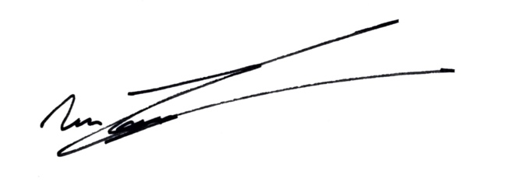

Appendix A – Deposit Cheque

