Form of authority/client consent form

Name:

Address:

Telephone no:

Email:

Date:

Signature:

I have instructed the AIRE Centre to assist and advise me with this issue.

I hereby give the AIRE Centre authorisation to communicate and to make representations on my behalf regarding all aspects of my case, and to provide legal representation as necessary and permitted by law.

I hereby authorise the release of any information relating to me or my case requested by the AIRE Centre as they see appropriate.

Please provide the AIRE Centre with copies of all correspondence relating to my case.

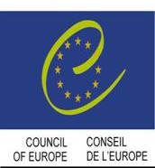

Participatory Status

Advice Line: +44 20 7831 4276 Fax: +44 20 7862 5765

e-mail: info@airecentre.org
Institute of Advanced Legal Studies, Room 505 Charles Clore House, 17 Russell Square, London WC1B 5DR
Company Limited by Guarantee, Reg. No. 2824400 Charity Registered No. 1090336

Organisation No. N200600055

